Latest Round-ups:
Season 2019/20
#11
Midweek Action: In a midweek dominated by cup ties, Hallen and Tavistock battled out a 1-1 draw in Tuesday’s lone league tie, with the hosts striking late to grab a share of the spoils. After an own goal had put Tavistock ahead 15 minutes from time, Kyle Thomas fired home an equaliser late in the game to maintain his sides spot in the top half of the table.
The remainder of the Tuesday fixtures saw a number of first round clashes in the Somerset Premier Cup, with Radstock producing the performance of the night. Drawn at home to Portishead, Radstock flew out of the traps and had built a three-goal lead inside the opening ten minutes thanks to goals from James Rustell, Morgan Marsh and Rico Sobers. Further goals after the break from Morgan Skipp and Jack Biddiscombe completed the victory, with the Miners eventually prevailing 5-1. Ashton & Backwell United will also take part in the second round after goals from Saul Jarrett and Harry Walker helped them defeat Wincanton 2-1. Two goals from Daryl Charman weren’t enough for Odd Down to mount a challenge against Paulton Rovers who won 5-3 at the Lew Hill Memorial Ground, while a first-half hat-trick from Adam Mann saw a strong Bath City outfit win 5-1 away at Shepton Mallet. Following a goalless draw at West Clewes, Welton Rovers were successful on spot kicks against Brislington to progress to the next round. Welton keeper Tom Drewitt saved from Jason Matthews, with Alex Wych then firing home the winning penalty to confirm victory for the Green Army.
In the tie of the round on Wednesday night, Keynsham twice came from behind to draw 3-3 away at Clevedon Town before inching past their hosts in a tight shootout. Goals from Lucas Vowles and George King had given Clevedon the lead on two occasions, only for Craig Wilson, and then Adey Harvey to knock in equalisers for the visitors. Keynsham then struck late, with Sam Downes putting them ahead for the first time, but Clevedon responded instantly with Ethan Feltham drawing them level a minute later. The game then headed to penalties, with Keynsham winning 5-4 to finally come out on top at the end of an entertaining clash. Street were knocked out by Larkhall on spot kicks following a 1-1 draw, while goalscoring doubles from Dale Hunt and Alex Camm helped Wells City claim a 5-1 win away at Wellington. There was also one Wiltshire Senior Cup tie, with Westbury defeating Royal Wootton Bassett 4-1 following goals from Matt Jones, Joe Stradling, Callum Demkiv and Sam Jordan.

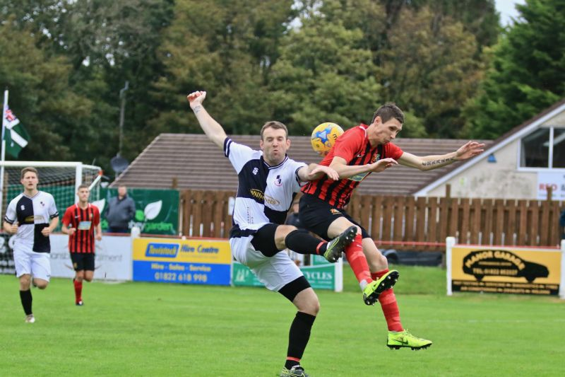
FA Vase: Shepton Mallet will be sick of the sight of Tavistock and Jack Crago, after the Devonians knocked them out of a second FA competition. Having played a huge role in their FA Cup demise earlier this season, Crago struck three times inside the opening 23 minutes on Saturday afternoon to lead the Lambs to a 4-1 victory in the first round of the FA Vase. Tavistock will be joined in the second round by county rivals Exmouth Town, after first half goals from Callum Shipton and Karl Rickard led them to a 2-0 victory over Portland United. The third Devon side to progress were Buckland Athletic, who claimed a 2-1 win away at Camelford. Both of the Bucks goals came prior to half-time, with Dan Harrison heading them ahead, before Stuart Bowker doubled their tally from a tight angle in the 24th minute. Bridgwater’s trip across the channel proved worthwhile after they secured a 2-0 victory away at Newport on the Isle of Wight. Town made an excellent start to the game, going ahead after just five minutes when Jake Brown headed home a Harry Horton free-kick. The home side then had a man sent off at the end of the first half, and Bridgy took advantage soon after the interval when the reliable Jake Llewellyn fired home from the spot following a foul on Brown. The performance of the day may have belonged to Roman Glass St George who battled back from a 3-1 deficit during the second half to defeat Malmesbury Victoria 5-3. Having trailed at the interval, Roman Glass levelled things early in the second half before their hosts struck twice in quick succession to gain control of the tie. The visitors then came to life, scoring four times in the final half hour to progress to the second round, with Ryan Radford, George Box, Jack Trott and Matt Guy all finding the back of the net. Bradford Town defeated Lymington Town 1-0 thanks to a first-half strike from Matty Morris, while Westbury United were knocked out by Badshot Lea following a 1-0 loss at Meadow Lane. Warminster Town had an impressive win at home to East Cowes Victoria Athletic, with second half goals from Charlie Walton and James Vincent helping them to secure a 3-2 victory at Weymouth Street.
Jack Crago in action for Tavistock during their 4-1 win away at Shepton Mallet. Image courtesy of Haydn Jones.
Premier Division: With other sides in Vase action, Wellington were one of the big movers in the Premier Division on Saturday, with the previous cellar dwellers beating Odd Down 5-0. Joe Chamberlain’s excellent volleyed finish gave the home side a half-time lead, with Matt Dawson doubling their advantage soon after the interval. Tom Hawkings put the result beyond doubt with a powerful header midway through the second half, with Chamberlain and then second-half sub Ollie Holman completing the victory.
Hallen now sit fourth in the table after twice from behind to defeat Clevedon Town 4-2 at the Hand Stadium. In one of the games of the day, Zach Drew handed Clevedon a 21st minute lead, before Aron Robbins levelled things just before half-time with his first Hallen goal. Jay Murray finished with aplomb to restore Clevedon’s advantage early in the second half, but the away side managed to get level once again when Kyle Thomas fired home from the penalty spot following a handball in the area. Robbins second goal of the afternoon handed Hallen their first lead 20 minutes from time, with the away side wrapping up victory in the closing stages through substitute Ed Bamfo. Cadbury Heath ended a spell of seven matches without a win by beating Chipping Sodbury Town 2-1 at Springfield. Matt Huxley proved to be the difference between the sides, scoring either side of a Justin Bishop penalty to hand the Heath a much-needed three points. Another player to score two vital goals in his side’s victory was Brislington forward Neikell Plummer, who added the finishing touches to crosses from Reeko Best and Lewis Dunn during their 2-1 win at home to Bridport. The individual performance of the day however, belonged to George Kellow who scored all three of Cribbs’ goals during their 3-2 win away at Street. Having fallen behind early in the contest, Kellow struck twice to hand his side a 2-1 lead after just 13 minutes. Street then levelled midway through the first half, and with a 2-2 draw looking the likely outcome, Kellow popped up with a winner six minutes from time to complete a magnificent hat-trick.
First Division: Calne Town produced a late fightback to beat Wells City 3-1 to move three points clear at the top of the table. Wells sharpshooter Harry Foster maintained his strong start to the campaign, opening the scoring after just 12 minutes at Bremhill View, but he missed out on the chance to double his tally after having a penalty saved early in the second half. Calne then came to life in the final 20 minutes, levelling the scores through recent signing Jamal Chevolleau. Having struck a hat-trick against Wells last season for former side Corsham, Chevolleau repeated the trick for Calne, scoring twice more in the final quarter hour of the contest to salvage an excellent victory. In another clash between current top-four sides, Longwell Green Sports defeated Wincanton Town 4-1 behind a hat-trick from Danny Carter. Lovejoy Mafini also got on the scoresheet for the hosts, but Carter was the star of the show, taking his tally for the season to nine goals from nine league games. Cheddar have now suffered four defeats from their last five games and conceding twice during the second half to lose 2-1 away at Radstock Town. The Cheesemen headed into the final quarter with a one-goal lead thanks to Robbi Maggs’ deflected effort, but they came unstuck at the hands of James Rustell, with the division’s top scorer scoring twice in the final 20 minutes to help Radstock climb to eighth on the ladder. Almondsbury have now gained nine points from a possible 12 over the last couple of weeks after claiming a 2-1 win away at Bristol Telephones. Greg Parr and Alex Bisp scored either side of the break for the Almonds, with the home side only threatening a late comeback after scoring a penalty five minutes from time.
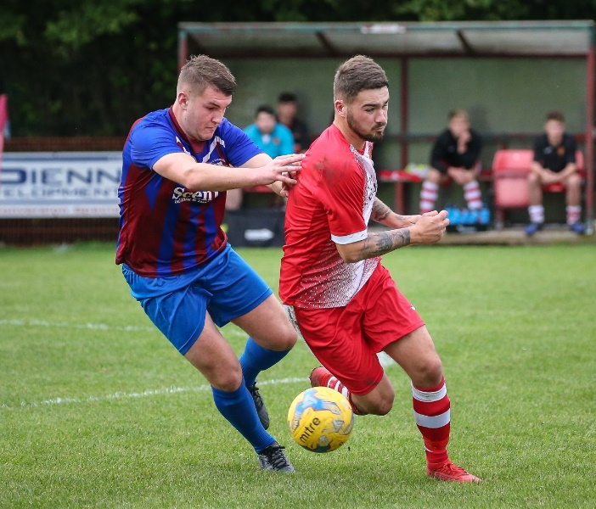
Ashton & Backwell United showed their fighting spirit, eventually drawing 3-3 with Corsham despite trailing throughout most of the game. Having taken a tenth minute lead through Luke Curtis, Corsham doubled their advantage four minutes later, when Curtis turned provider, supplying the assist for Josh Bright to fire home. The home side then struck twice at the end of the first half, through a Joe Bishop penalty and a Harry Walker header, to claim a share of the spoils as the half-time whistle blew. Corsham pulled ahead again on the hour mark when Leigh Rogers’ through ball was buried by Josh Hard, but Ashton never lay down, claiming a point thanks to Charlie Rich’s pinpoint free-kick in the 90th minute. Welton Rovers claimed their first three points in over a month after squeezing past Lebeq United by three goals to two at West Clewes. After an early own-goal had put Lebeq ahead, Sean Hatcher drew the Green Army level after being slipped in by Chris Pile to open his account for the club. Liam Evans then completed the turnaround a couple of minutes later, before the visitors hit back in first half stoppage time thanks to a 20-yard strike from Dan Payne. The chances dried up in the second half, but it ended on a huge high note for Welton, with captain Tom Smith sliding the ball home from inside the six-yard box to secure a dramatic victory. Devizes and Bishop Sutton both remain in the bottom four and battling out a goalless draw at Nursteed Road.
Action from Ashton & Backwell’s 3-3 draw with Corsham. Image courtesy of John Cuthbertson.

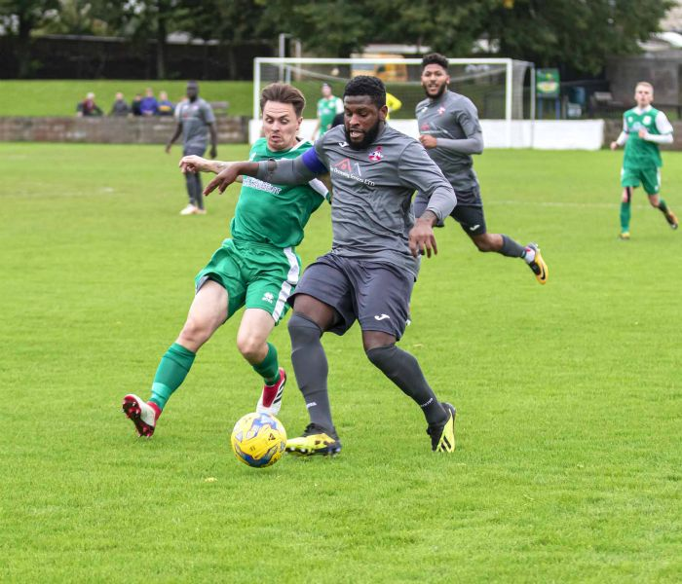
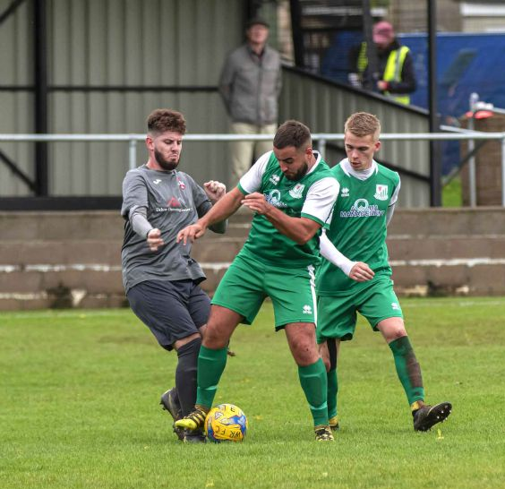

Action from Welton Rovers 3-2 victory over Lebeq United, courtesy of MIP Photography.

Western League Statistical Leaders

PREMIER DIVISION LEADING GOAL SCORERS (League only):
Adam Carter (Plymouth Parkway) – 16
Jack Taylor (Bridgwater Town) – 9
Jack Fillingham (Shepton Mallet) – 9
Lucas Vowles (Clevedon Town) – 9
Josh Egan (Bitton) – 9

PREMIER DIVISION TOP ATTENDANCES:
Bridport 0 Bridgwater Town 6, Sunday 6th October 2019 – 347
Wellington 0 Exmouth Town 2, Sunday 6th October 2019 - 315
Plymouth Parkway 1 Exmouth Town 0, Wednesday 21st August 2019 - 308

FIRST DIVISION LEADING GOAL SCORERS (League only):
James Rustell (Radstock Town) – 13
Harry Foster (Wells City) – 10
Stuart Windsor (Calne Town) – 9
Danny Carter (Longwell Green Sports) – 9

FIRST DIVISION TOP ATTENDANCES:
Warminster Town 2 Bristol Telephones 3, Saturday 5th October - 369
Portishead Town 3 Longwell Green Sports 5, Saturday 5th October – 262
Devizes Town 0 Ashton & Backwell United 1, Saturday 5th October – 252

LEADING SCORERS IN ALL COMPETITIONS:
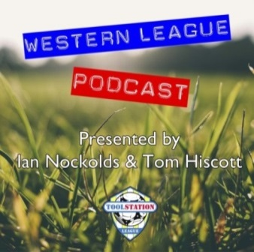
Jack Crago (Tavistock) - 20
James Rustell (Radstock Town) – 18
Adam Carter (Plymouth Parkway) – 16
Harry Foster (Wells City) – 13
Jack Taylor (Bridgwater Town) - 12
Jack Fillingham (Shepton Mallet) – 12
Lucas Vowles (Clevedon Town) – 11
Stuart Windsor (Calne Town) – 10
Gary Higdon (Bradford Town) – 10

Be sure to check out the latest podcast, where Ian, Tom & guests recap all the latest news and results from around the Western League. To follow along all season, each broadcast will be available at the following link: http://www.toolstationleague.com/podcasts.php

*All goalscoring stats via
Full-Time FA website

Latest Results
Tuesday 8th October 2019
Premier Division
Hallen 1-1 Tavistock 42
Somerset FA Premier Cup – First Round
Ashton & Backwell United 2-1 Wincanton Town 47
Odd Down 3-5 Paulton Rovers 63
Radstock Town 5-1 Portishead Town 45
Shepton Mallet 1-5 Bath City 158
Welton Rovers 0-0 (4-3 pens) Brislington 68
Wednesday 9th October 2019
Somerset FA Premier Cup – First Round
Clevedon Town 3-3 (4-5 pens) Keynsham Town 94
Larkhall Athletic 1-1 (5-4 pens) Street
Wellington 1-5 Wells City 40
Wiltshire FA Senior Cup – First Round
Westbury United 4-1 Royal Wootton Bassett 42
Saturday 12th October 2019
FA Vase – First Round
Bitton P-P Tadley Calleva
Bradford Town 1-0 Lymington Town 122
Camelford 1-2 Buckland Athletic
Exmouth Town 2-0 Portland United
Malmesbury Victoria 3-5 Roman Glass St George
Newport (IoW) 0-2 Bridgwater Town 144
Romsey Town P-P Plymouth Parkway
Tavistock 4-1 Shepton Mallet
Warminster Town 3-2 East Cowes Victoria Athletic 133
Westbury United 0-1 Badshot Lea 71
Premier Division
Brislington 2-1 Bridport 69
Cadbury Heath 2-1 Chipping Sodbury Town 53
Clevedon Town 2-4 Hallen 118
Street 2-3 Cribbs 82
Wellington 5-0 Odd Down 42
First Division
Ashton & Backwell United 3-3 Corsham Town 105
Bristol Telephones 1-2 Almondsbury 42
Calne Town 3-1 Wells City 63
Devizes Town 0-0 Bishop Sutton 65
Hengrove Athletic P-P Sherborne Town
Longwell Green Sports 4-1 Wincanton Town 94
Oldland Abbotonians P-P Portishead Town
Radstock Town 2-1 Cheddar 71
Welton Rovers 3-2 Lebeq United 72

Upcoming Fixtures
Tuesday 15th October 2019
FA Vase – First Round
Bitton vs Tadley Calleva 19:30KO
Premier Division
Bridport vs Buckland Athletic 19:45KO
Cribbs vs Roman Glass St George 19:45KO
Keynsham Town vs Shepton Mallet 19:45KO
Wednesday 16th October 2019
FA Vase – First Round
Romsey Town vs Plymouth Parkway 19:45KO
Premier Division
Bradford Town vs Brislington 19:30KO
Exmouth Town vs Street 19:45KO
Friday 18th October 2019
First Division
Wells City vs Oldland Abbotonians 19:30KO
Saturday 19th October 2019 (KICK OFF AT 3.00PM UNLESS NOTED)
Premier Division
Bridgwater Town vs Bitton
Bridport vs Hallen
Clevedon Town vs Brislington
Cribbs vs Bradford Town
Keynsham Town vs Exmouth Town
Plymouth Parkway vs Shepton Mallet
Roman Glass St George vs Chipping Sodbury Town
Street vs Buckland Athletic
Tavistock vs Westbury United
Wellington vs Cadbury Heath
First Division
Ashton & Backwell United vs Warminster Town
Bishop Sutton vs Bishops Lydeard
Cheddar vs Longwell Green Sports
Corsham Town vs Almondsbury
Hengrove Athletic vs Lebeq United
Portishead Town vs Devizes Town
Sherborne Town vs Radstock Town
Welton Rovers vs Calne Town
Wincanton Town vs Bristol Telephones

League Tables
Premier Division
 |  | P | W | D | L | F | A | GD | PTS
1 | Plymouth Parkway | 9 | 7 | 1 | 1 | 39 | 7 | 32 | 22
2 | Bradford Town | 8 | 7 | 0 | 1 | 20 | 9 | 11 | 21
3 | Bridgwater Town | 9 | 6 | 2 | 1 | 32 | 11 | 21 | 20
4 | Hallen | 10 | 5 | 2 | 3 | 21 | 23 | -2 | 17
5 | Westbury United | 9 | 5 | 1 | 3 | 19 | 15 | 4 | 16
6 | Clevedon Town | 10 | 5 | 1 | 4 | 23 | 25 | -2 | 16
7 | Bitton | 8 | 5 | 0 | 3 | 25 | 12 | 13 | 15
8 | Exmouth Town | 6 | 5 | 0 | 1 | 13 | 2 | 11 | 15
9 | Street | 9 | 5 | 0 | 4 | 21 | 18 | 3 | 15
10 | Brislington | 11 | 5 | 0 | 6 | 19 | 27 | -8 | 15
11 | Shepton Mallet | 7 | 4 | 1 | 2 | 17 | 10 | 7 | 13
12 | Cribbs | 10 | 4 | 1 | 5 | 12 | 21 | -9 | 13
13 | Cadbury Heath | 11 | 3 | 3 | 5 | 16 | 24 | -8 | 12
14 | Tavistock | 6 | 3 | 1 | 2 | 16 | 11 | 5 | 10
15 | Odd Down | 11 | 3 | 1 | 7 | 13 | 29 | -16 | 10
16 | Buckland Athletic | 8 | 3 | 0 | 5 | 12 | 17 | -5 | 9
17 | Wellington | 11 | 3 | 0 | 8 | 14 | 30 | -16 | 9
18 | Keynsham Town | 8 | 2 | 2 | 4 | 18 | 22 | -4 | 8
19 | Bridport | 11 | 2 | 1 | 8 | 17 | 34 | -17 | 7
20 | Chipping Sodbury Town | 11 | 2 | 1 | 8 | 12 | 36 | -24 | 7
21 | Roman Glass St George | 7 | 2 | 0 | 5 | 13 | 9 | 4 | 6

First Division
 |  | P | W | D | L | F | A | GD | PTS
1 | Calne Town | 10 | 6 | 2 | 2 | 17 | 6 | 11 | 20
2 | Wincanton Town | 9 | 5 | 2 | 2 | 20 | 16 | 4 | 17
3 | Wells City | 9 | 5 | 1 | 3 | 23 | 15 | 8 | 16
4 | Longwell Green Sports | 9 | 5 | 1 | 3 | 21 | 16 | 5 | 16
5 | Ashton & Backwell United | 9 | 4 | 4 | 1 | 14 | 11 | 3 | 16
6 | Oldland Abbotonians | 10 | 4 | 4 | 2 | 9 | 9 | 0 | 16
7 | Cheddar | 8 | 5 | 0 | 3 | 17 | 12 | 5 | 15
8 | Radstock Town | 9 | 5 | 0 | 4 | 22 | 18 | 4 | 15
9 | Sherborne Town | 8 | 5 | 0 | 3 | 16 | 15 | 1 | 15
10 | Almondsbury | 9 | 4 | 1 | 4 | 15 | 14 | 1 | 13
11 | Corsham Town | 10 | 4 | 1 | 5 | 18 | 30 | -12 | 13
12 | Portishead Town | 8 | 4 | 0 | 4 | 22 | 18 | 4 | 12
13 | Lebeq United | 9 | 4 | 0 | 5 | 19 | 21 | -2 | 12
14 | Bishops Lydeard | 8 | 3 | 1 | 4 | 16 | 12 | 4 | 10
15 | Welton Rovers | 9 | 3 | 1 | 5 | 11 | 19 | -8 | 10
16 | Warminster Town | 8 | 3 | 0 | 5 | 17 | 14 | 3 | 9
17 | Devizes Town | 9 | 2 | 3 | 4 | 18 | 18 | 0 | 9
18 | Hengrove Athletic | 9 | 2 | 3 | 4 | 6 | 23 | -17 | 9
19 | Bishop Sutton | 9 | 2 | 1 | 6 | 11 | 16 | -5 | 7
20 | Bristol Telephones | 9 | 1 | 1 | 7 | 13 | 22 | -9 | 4

